# Lab: Hibernate Configuration

This **tutorial** provides step-by-step guidelines to setup your Hibernate settings. You will learn how to configure your executable jar files. There will be a good explanation on how to run **java** **jar** programs powered by **CGI scripts** in order to properly **persist** your objects.

## Dependencies

You will need only two dependencies for to run **hibernate**. The first one is hibernate itself. Use version **5.x.x** The second dependency should be **MySQL connector**. Again use version above **5**. See the example below:

|  |
| --- |
| **pom.xml** |
| <**dependencies**>  <**dependency**>  <**groupId**>mysql</**groupId**>  <**artifactId**>mysql-connector-java</**artifactId**>  <**version**>5.1.38</**version**>  </**dependency**>  <**dependency**>  <**groupId**>org.hibernate</**groupId**>  <**artifactId**>hibernate-core</**artifactId**>  <**version**>5.2.5.Final</**version**>  </**dependency**> </**dependencies**> |

#### Persistence

Hibernate requires **persistence.xml** file. Is should be located in **resources/META-INF/.** You have to configure your **database credentials**. Set a proper name of the **persistence unit**.

|  |
| --- |
| **persistence.xml** |
| <**persistence xmlns="http://java.sun.com/xml/ns/persistence"  xmlns:xsi="http://www.w3.org/2001/XMLSchema-instance"  xsi:schemaLocation="http://java.sun.com/xml/ns/persistence http://java.sun.com/xml/ns/persistence/persistence_2_0.xsd"  version="2.0"**>  <**persistence-unit name="unit"**>  <**properties**>  <**property name="javax.persistence.jdbc.driver" value="com.mysql.jdbc.Driver"**/>  <**property name="javax.persistence.jdbc.url" value="jdbc:mysql://localhost/database_name?createDatabaseIfNotExist=true"**/>  <**property name="javax.persistence.jdbc.user" value="user"**/>  <**property name="javax.persistence.jdbc.password" value="password"**/>  <**property name="hibernate.dialect" value="org.hibernate.dialect.MySQL5InnoDBDialect"**/>  <**property name="hibernate.hbm2ddl.auto" value="update"**/>  </**properties**>  </**persistence-unit**> </**persistence**> |

#### Executable Jar

The last thing required to run **Hibernate** is to create an **executable jar file**. Go to **File->Project Structure->Artifacts.**Create a new artifact that would be a **jar file**. Select **+->JAR->From modules with dependencies**.

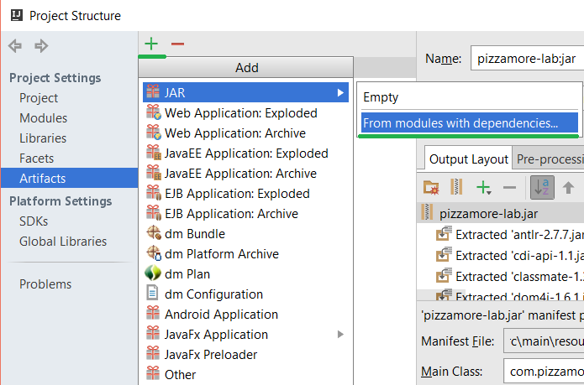

Create a **manifest file**. It should be located in **resources/META-INF**. Choose the class that should be your starting point.

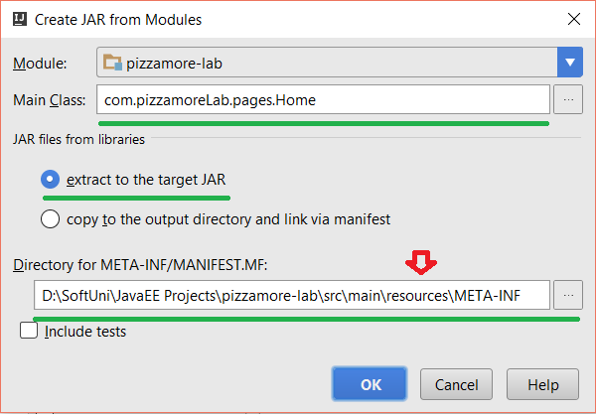

Include all the hibernate jars **extracted**. Make **build on make** active.

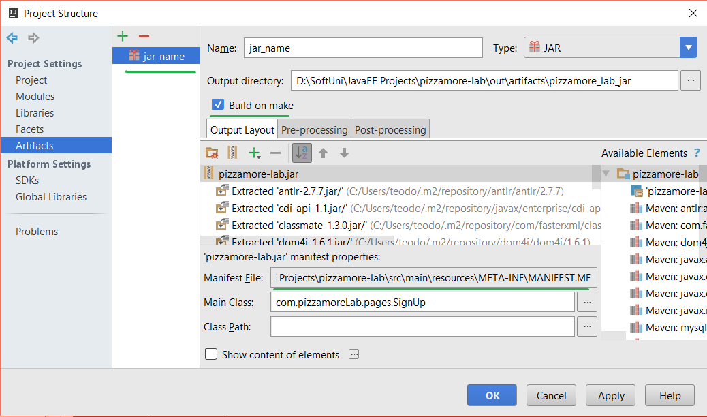

## CGI Script

The last step is to create a script that would call your jar file.

|  |
| --- |
| **main.cgi** |
| #!C:\cygwin64\bin\bash.exe  chcp 65001  java -Dcgi.request_method=$REQUEST_METHOD -Dcgi.query_string=$QUERY_STRING **-jar Home.jar** $HTTP_COOKIE |